11 Feb 2019

Brandon M. Quinby

Department of Forestry and Natural Resources

Purdue University

715 W. State Street

PFEN Room G004

West Lafayette, IN 47907

(765) 413-8141

bquinby@purdue.edu

**Evaluation of the Prey Base and Feeding Relationships of the American Burying Beetle (*Nicrophorus americanus*) on Nantucket Island**

BRANDON M. QUINBY, *Purdue University, 715 W. State Street, West Lafayette, IN 47907, USA*

ELIZABETH A. FLAHERTY, *Purdue University, 195 Marsteller Street, West Lafayette, IN 47907, USA*

J. CURTIS CREIGHTON, *Purdue University Northwest, 2200 169th Street, Hammond, IN 46323, USA*

**Abstract**

The American burying beetle, *Nicrophorus americanus*, (ABB), once widely distributed across the eastern two-thirds of North America, has recently experienced a dramatic decline in abundance and geographic range. In 1989, the ABB was listed as a federally endangered species. The last recorded naturally occurring ABB on Nantucket Island, Massachusetts was in 1926. Beginning in 1994, lab-reared offspring of wild-caught individuals from Block Island, Rhode Island were used to reintroduce the ABBonto Nantucket. Despite an initially successful reintroduction, the population shows little evidence of recruitment and likely requires human assistance for long-term success. A key requirement of the ABB’s life cycle is the availability of small vertebrate carcasses used for breeding. Despite over 30 years of research*,* we know little about the preferred carrion base necessary to support a healthy ABB population. In this study, we investigated feeding relationships of local burying beetles using stable isotope analysis (δ13C and δ15N) conducted on small elytral clips collected from live-captured specimens. Because burying beetles build body tissues using nutrients from their larval host carcass, the stable isotope ratios of δ13C and δ15N in adult burying beetles reflect their larval diet, indicating the carrion their parents used as a reproductive resource. We found a significant difference in δ13C and δ15N values among wild-caught burying beetle species. Additionally, δ13C and δ15N values differed significantly among wild-caught burying beetle species and potential carrion. This allows us to identify the small vertebrate species and the size of individual carrion used by *N. americanus* for reproduction.

**Introduction**

*Nicrophorus americanus* was once widely distributed across the eastern two-thirds of North America but has recently undergone a dramatic decline in its geographic range and abundance (Anderson 1982; Lomolino *et al.* 1995). Sikes and Raithel 2002 proposed several hypotheses to explain the species decline, but it is likely that two of the primary factors leading to its endangered status are its relatively large size and specialized breeding behavior. Reintroduction efforts are underway or have been attempted in Ohio, Missouri and Massachusetts (on Nantucket Island).

The 2016 surveys on Nantucket documented the lowest number of captures in the 23 years of organized surveys (L. Perrotti pers. comm.). Despite a successful initial introduction to Nantucket, the population is not self-sustaining and may require human assistance for long-term maintenance (McKenna-Foster *et al.* 2016). Although studied extensively relative to habitat use (Creighton *et al.* 1993; Lomolino *et al.* 1995; Bedick *et al.* 1999), our study quantifies feeding relationships and availability of preferred food sources for *N. americanus* in a natural environment. Burying beetles use carrion for both nonreproductive feeding and for reproduction as food for their offspring. However, locating appropriate small vertebrate carcasses for breeding and raising offspring is more difficult than finding carrion on which to feed. Currently there is a lack of knowledge of species and size of small vertebrate species are used by *N. americanus* for reproduction, which challenges appropriate management of known *N. americanus* habitat. Thus, characterizing suitable habitat and managing existing and reintroduced *N. americanus* populations depend on knowing the distribution and availability of all food sources. Furthermore, interspecific interactions among burying beetles can influence reproduction and establishment of reintroduced *N. americanus.* It is therefore important to understand interspecific interactions among members of the burying beetle community to better evaluate factors effecting population dynamics.

Because stable isotope signatures of body tissues reflect the assimilated diet of the individual (Gannes et al. 1998; Zah et al. 2001; Ben-David and Flaherty 2012), they can provide quantitative information on resource use and width of the organisms’ ecological niche (Newsome et al. 2007, Flaherty and Ben-David 2010, Eckrich et al. 2018). Additionally, when determining resource use and the width of an organism’s ecological niche using stable isotope analysis, it is important to collect a variety of local, representative samples of potential food sources that are reflective of different dietary niches (Ben-David and Schell 2001, Phillips 2001, Flaherty et al. 2010). Because burying beetles grow and develop on a single food source (i.e. a single individual, small vertebrate) the body tissues of the adult beetles reflect the nitrogen-carbon isotopic signature of their larval food source, including the elytra (Gratton and Forbes 2006). Importantly, we can remove small samples of the elytra without affecting the survival of *N. americanus*. By employing stable isotope techniques we determined the small vertebrate carrion base used as reproductive food resource for *N. americanus* and other locally abundant burying beetles in a natural environment.

**Methods**

*Study Area*

We collaborated with the Roger Williams Park Zoo, USFWS, the Maria Mitchell Association, and the Nantucket Conservation Foundation and used pitfall trapping sites that were located on the eastern side of the island (Fig. 1). We employed the same grid system used in previous years surveys from 2013 – 2017. Trap sites 2 and 13 were abandoned after 2013 and are not listed. The average distance between a site and its four closest neighbors is 1.96 ± 0.57 km. Assuming each trap line has an effective range of 0.8 km (USFWS 2013), the grid system covers 22.7 km2.

*Pitfall Trapping*

We set traps on the night of 13 June 2018 and trapped continuously until 25 June 2018. Due to low trapping success, traps at site 1, 3, and 4 were closed 21 June, and we closed site 14 on 22 June. We placed 5 pitfall traps at all sights approximately 20 m apart in a straight line. We followed the ongoing trapping protocol originally described by Kozol (1991). Each pitfall trap consisted of a 946 ml mason jar buried with the top level to the soil. We placed a small plastic container with a screw-on mesh lid, which we filled with aged chicken, inside of each pitfall trap. We prepared the chicken beforehand in plastic containers which we left at room temperature for 7-8 days prior to baiting the traps. We also placed a moist sponge in each trap to help prevent beetle desiccation. We covered each jar with a square piece of hardware cloth with a 3 x 3 cm hole in the middle that allowed beetles access to the trap and helped prevent other wildlife from disturbing them. We placed a disposable aluminum pan lid that we bent to resemble a “tent” over the pitfall trap and staked it down with ground staples to keep out rain and to provide shade. We checked traps every morning between 0600 and 1000 EST to ensure that all burying beetles were removed before traps became lethally warm. All *N. americanus* captured were collected in single occupancy containers to await provisioning, and a subset of the other burying beetle species captured were frozen until they were processed for analysis.

*Field Sample Collection*

We collected tissue for stable isotope analysis in June of 2017 and 2018 from 4 species of burying beetles (*N. americanus, N. orbicollis, N. tomentosus*, and *N. marginatus*; Table 1). To determine feeding relationships of *N. americanus*, we analyzed stable isotopes (δ13C and δ15N) using a small clip from the elytra of live-captured specimens; we used the whole elytra for all other burying beetle species. All samples for stable isotope analysis were collected during the peak reproductive season in mid-summer.

To compare to the signatures of the burying beetle species and determine carrion food sources, we collected whole blood and muscle tissue samples from locally available small mammals, and birds, for 2017 and 2018 (Table 2). We based the species sampled on small mammal and bird surveys previously conducted by Massachusetts Division of Fisheries and Wildlife. Most of these species range between 100-300 g (Schwartz and Schwartz 2001) and could provide a suitable carrion base for *N. americanus*. The goal in our sampling was to represent variation in size and functional groups (e.g., herbivores versus insectivores) of the small vertebrate fauna.

Small mammal whole blood samples were collected by Danielle O’Dell (Nantucket Conservation Foundation) using submandibular venipuncture, during her ongoing small mammal survey in July and September 2017 and 2018. Avian whole blood samples were collected using brachial venipuncture. Mist netting for avian samples was facilitated by Dr. Richard Viet and Ginger Andrews on June 23rd 2017 and June 13th and 20th 2018. Additional muscle tissue samples (1-3 g) from mammals and birds were provided from frozen carcasses by the Maria Mitchell Association in June of 2017 (Table 2).

None of the potential prey species collected were of conservation concern on Nantucket. All methods involving live vertebrates were approved by Purdue University’s Institutional Animal Care and Use Committee (PACUC # 1705001577) and followed recommendations by the Ornithological Council (Fair et al. 2010) and the American Society of Mammologists (Sikes et al. 2016).

*Stable Isotope Sample Analysis*

In the laboratory, all samples were dried at 60°C for 48 hr and then homogenized and ground into a fine powder using a mixer mill (Retsch MM 200, Glen Mills Inc., Clinton, NJ). Two subsamples (duplicates) were weighed to the nearest 0.01 mg (Sartoris CPA2P, Data Weighing Systems Inc., Elk Grove, IL) and placed in a miniature tin weigh boat (3 x 5 mm; Costech Analytical Technologies, Valencia, CA). All samples were sent to the University of Wyoming Stable Isotope Facility (UWSIF; University of Wyoming, Laramie, WY) for analysis of δ13C and δ15N using an elemental analyzer and isotope ratio mass spectrometer (Thermo Finnigan Delta Plus XP, Costeck 4010 and Carlo Erba 1110 Elemental Analyzer, Costec Zero Blank Autosampler, Finnigan Conflo III Interface).

*Statistical analysis*

We used a MANOVA and Tukey’s HSD (Zar 2010) to evaluate and compare isotopic signatures among vertebrate prey. Based on these results, we categorized potential reproductive food resources (Brown rats, Mammals, Birds, Sea-birds, and Farm raised quail; Table 2.) Similarly, we used a MANOVA (SAS Proc MIXED; SAS Institute 2000; Gratton and Forbes 2006) to assess differences in isotopic signature among species of burying beetles and potential prey. Because of sample turnaround time our preliminary analysis of 2018 burying beetles only includes *N. americanus*. All remaining burying beetle and carrion samples from 2018 have been processed and sent to the University of Wyoming Stable Isotope Facility (University of Wyoming, Laramie, WY) for analysis using an elemental analyzer and isotope ratio mass spectrometer (Thermo Finnigan Delta Plus XP, Costeck 4010 and Carlo Erba 1110 Elemental Analyzer, Costec Zero Blank Autosampler, Finnigan Conflo III Interface). Additionally, due to low sample size (n=1), we did not include *N. tomentosus* in our analysis. An updated report which will include all 2017 and 2018 samples will be presented at the 2019 Nantucket Biodiversity Initiative Conference.

**Results**

We found a significant difference in δ13C and δ15N values among different species of wild-caught burying beetles (F (6,148) = 13.32; p<0.01; Wilk’s Λ = 0.422; partial η2 = 0.351; Fig. 2). Values for δ13C and δ15N differed significantly between wild-caught burying beetle species (F (3,75) = 14.42; p<0.01; partial η2 = 0.37; and F (3,75) = 19.47; p<0.01; partial η2 = 0.44; respectively). *Nicrophorus americanus* from 2017 had significantly different δ13C values (Tukey’s HSD: p<0.01) than both *N. orbicollis* and *N. marginatus*, but δ13C values were not significantly different from 2018 *N. americanus* (Tukey’s HSD: p=0.998). Conversely, the δ15N values were significantly different between 2017 *N. americanus* and both 2018 *N. americanus* and *N. marginatus* (Tukey’s HSD: p<0.01; Tukey’s HSD: p<0.01) respectively.

Additionally, δ13C and δ15N values differed significantly among potential reproductive carrion (F (8,210) = 52.56; p<0.01; Wilk’s Λ = 0.111; partial η2 = 0.67; Fig. 2). The δ13C values were significantly different between sea birds and all other potential reproductive carrion (Tukey’s HSD: p<0.01), except farm raised quail (Tukey’s HSD: p=0.071). Values for δ13C between mammals and Norway rats did not differ significantly (Tukey’s HSD: p=1.00). Additionally values for δ13C between and mammals and birds did not differ significantly (Tukey’s HSD: p=0.362), but they significantly differed between mammals and quail (Tukey’s HSD: p<0.01; Tukey’s HSD).Values for δ13C in Norway rats and birds were not significantly different (Tukey’s HSD: p=0.911). However, there was a significant difference between δ13C values between quail and other birds (Tukey’s HSD: p<0.01), as well as between quail and Norway rats (Tukey’s HSD: p<0.01).

The δ15N values were significantly different between seabirds and all other potential reproductive carrion (Tukey’s HSD: p<0.01). Values for δ15N in mammals and quail did not differ between one another (Tukey’s HSD: p=0.864) however, δ15N values in both mammals and quail differed from δ15N values in birds, Norway rats, and sea birds (Tukey’s HSD: p<0.01; p<0.01; p<0.01 respectively). Additionally, δ15N values in birds and Norway rats were not significantly different between groups (Tukey’s HSD: p=1.00)

**Discussion**

Most burying beetle communities are characterized by a broad overlap in habitat use (Anderson 1981, Lomolino et al*.* 1995), and ecological opportunity such as available carrion type, success in locating carcasses, competition with other species, and breeding on a carcass can influence niche variation within and among species and may differ among habitats and over time. It is well documented that different burying beetle species exhibit preference for carcass size (Scott 1998); however, it is still unclear if individual species have resource preference beyond carcass mass (i.e. preference for small mammals or birds). Our use of stable isotope analysis will allow for identification of the species of small vertebrates used by *N. americanus* for reproduction and provide more insight into consequent feeding relationships within local assemblages of burying beetles.

Differences in carbon isotope signatures based on C3 and C4 crop plants can be used to study food preferences (Akamatsu et al*.* 2004; Feldhaar, Gebauer, and Blüthgen 2010), and feeding strategies (Trimble and Sagers 2004), whereas differences in nitrogen isotope signatures can be used to assess trophic position (Peterson and Fry 1987;Post 2002).

As predicted, we identified a significant difference in δ13C and δ15N values among different species of wild-caught burying beetles. These differences are thought to be a result of interspecific interactions among burying beetles that influences which reproductive food resources are utilized by each species. The significantly different δ13C values detected in *N. americanus* suggest that the individuals in the population are relying on different carrion for reproductive feeding resources, when compared to *N. orbicollis* and *N. marginatus*. An explanation for the more positive signatures in δ13C values in *N. americanus*,may be a result of provisioning of farm raised quail for *N. americanus* pairs. The only significant difference in δ15N values were detected between 2017 *N. americanus* and both 2018 *N. americanus* and *N. marginatus* with *N. orbicollis* falling between the other two species. This is expected, as burying beetles communities have large overlap in habitat use (Lomolino *et al.* 1995), but further analysis that includes samples being processed at UWSIF will allow us to assess the proportion of reproductive diet that carrion categories play in local burying beetle communities using Stable Isotope Mixing Models.

**Acknowledgements**

I would like to thank Dr. Emily Goldstein-Murphy, and Lou Perrotti for their guidance and aid on this project. The interns at the Maria Mitchell Museum, Elisabeth Sorrows, Rachel Althoff, and Clare Cunningham for their assistance in the field and cataloging samples. Dr. Richard Viet and Ginger Andrews for accommodating this project in their ongoing mist netting and avian surveys. Danielle O’Dell for collecting small mammal blood samples during her small mammal surveys. The project was made possible thanks to funding and support from multiple institutions, including: Nantucket Biodiversity Initiative, the Maria Mitchell Association, the Nantucket Conservation Foundation, the University of Massachusetts Boston Field Station, the Theodore Roosevelt Memorial Fund of the American Museum of Natural History, and the Purdue University Department of Forestry and Natural Resources.

**Literature Cited**

Akamatsu, F., Toda, H. and Okino, T. (2004). Food source of riparian spiders analyzed by using stable isotope ratios. Ecological Research, **19**(6), 655-662.

Anderson, R.S. (1981). Resource partitioning in the carrion beetle (Coleoptera:Silphidae) fauna of southern Ontario: ecological and evolutionary considerations. Canadian Journal of Zoology. **60**(6), 1314-1325.

Anderson, R. S. (1982). On the decreasing abundance of *Nicrophorus americanus* Olivier (Coleoptera: Silphidae) in eastern North America. *Coleopterists Bulletin*. **36**: 362-365.

Bedick, J. C., Ratcliffe B. C., Hoback W. W. and Higley L. G. (1999). Distribution, ecology, and population dynamics of the American burying beetle [*Nicrophorus americanus* Olivier (Coleoptera, Silphidae)] in south-central Nebraska, USA. *Journal of Insect Conservation.* **3**: 171-181.

Ben-David, M. and, Schell, D.M. (2001). Mixing models in analyses of diet using multiple stable

isotopes: a response. *Oecologia*, **127**(2):180-184.

Ben-David, M., and Flaherty E.A. (2012). Stable isotopes in mammalian research: a beginner’s

guide. *Journal of Mammalogy* **93**:312-328.

Creighton, J. C., Vaughn, C. C. and Chapman, B. R. (1993). Habitat preference of the endangered American burying beetle (*Nicrophorus americanus*) in Oklahoma. *Southwest. Nat*. **38**: 275-277.

Eckrich, C. A., Flaherty, E. A., and Ben-David, M. (2018). Functional and numerical responses of shrews to competition vary with mouse density. *PloS one*, **13**(1), e0189471

Erhardt, E.B., Wolf, B. O., Ben-David, M., and Bedrick, E. J. (2014). Stable isotope sourcing using sampling. *Open Journal of Ecology* **4**:289-298.

Fair, J., Paul, E., and Jones, J. Eds. (2010). Guidelines to the use of wild birds in research. Washington, D.C.: Ornithological Council.

Feldhaar, H., Gebauer, G. & Blüthgen, N. (2010). Stable isotopes: past and future in exposing

secrets of ant nutrition (Hymenoptera: Formicidae). Myrmecological News, **13**:3-13.

Flaherty, E.A., M. Ben-David, and W.P. Smith. (2010). Diet and food availability: implications for foraging and dispersal of Prince of Wales northern flying squirrels across managed landscapes. *Journal of Mammalogy*, **91**(1):79-91.

Gannes, L. Z., Del Rio, C. M., and Koch, P. (1998). Natural abundance variations in stable isotopes and their potential uses in animal physiology ecology. *Comparative Biochemical Physiology* **119**:725-737.

Gratton, C., and Forbes, A. E. (2006). Changes in δ13C stable isotopes in multiple tissues of insect predators fed isotopically distinct prey. Oecologia **147**:615-624.

Kozol A. (1991). Appendix 2. Survey protocol for Nicrophorus americanus, the American

burying beetle [pp. 1–6]. In: U.S. Fish and Wildlife Service, American Burying Beetle (Nicrophorus americanus) Recovery Plan. Newton Corner, MA. 80 pp.

Lomolino, M. V., Creighton, J. C., Schnell, G. D. and Certain, D. L. (1995). Ecology and conservation of the endangered American burying beetle (*Nicrophorus americanus*). *Conservation Biology.* **9**: 605-614.

McKenna-Foster, A., Perrotti, L., Blyth, J., LoPresti, E., and Kennedy, R. S. (2016). Measuring success of a reintroduced population of the American burying beetle (*Nicrophorus americanus* Olivier) to Nantucket Island, MA. *Journal of Insect Conservation* **20**:895-904.

Newsome, S.D., C.M. del Rio, S. Bearhop, and Philips, D.L. (2007). A niche for isotopic ecology. *Frontiers in Ecology and the Environment* **5**:429-436.

Peterson, B.J., & Fry, B. (1987). Stable isotopes in ecosystem studies. Annual Review Ecological Systematics. **18**:293-320.

Phillips, D.L. (2001). Mixing models in analyses of diet using multiple stable isotopes: a critique. *Oecologia*, **127**(2):166-170.

Post, D. M. (2002). Using stable isotopes to estimate trophic position: models, methods, and assumptions. Ecology 83:703-718.

Schwartz, C. W. and Schwartz, E. R. (2001) The wild mammals of Missouri. University of Missouri Press.

Scott, M.P. (1998). The ecology and behavior of burying beetles. Annual Review of Entomology. research **43**(1), 595-618.

Sikes D. S. and Raithel, C. J. (2002). A review of hypotheses of decline of the endangered American burying beetle (Silphidae: *Nicrophorus americanus* Olivier). *Journal of Insect Conservation* **6**: 103-113.

Sikes R. S. and the Animal Care and Use Committee of the American Society of Mammalogist. (2016). 2016 Guidelines of the American Society of Mammalogist for the use of wild mammals in research and education. *Journal of Mammalogy* **97**(3):663-688.

Trimble, S.T. & Sagers, C.L. (2004). Differential host use in two highly specialized ant-plant associations: evidence from stable isotopes. Oecologia, **138**(1), 74-82.

Zah R., Burgherr, P., Bernasconi, S. M., and Uehlinger U. (2001). Stable isotope analysis of macroinvertebrates and their food sources in a glacier stream. *Freshwater Biology* **46**: 871–882.

Zar, J. H. (2010). Biostatistical analysis. 5th ed. Prentice Hall, Upper Saddle River, New Jersey.

**Tables**

**Table 1.** Wild-caught burying beetles from Nantucket Island, MA June 2017 and 2018. *Nicrophorus tomentosus* was not included in the analysis due to a small sample size.

|  |  |
| --- | --- |
| **Species** | **N** |
| 2017 *N. americanus* | 23 |
| 2018 *N. americanus* | 5 |
| *N. orbicollis* | 36 |
| *N. marginatus* | 20 |
| *N. tomentosus* | 1 |

**Table 2.** Small mammal and avian species collected in June of 2017 to determine potential carrion reproductive food source. Includes tissue type collected, sample source (Nantucket Maria Mitchell Association, Road Kill, Live Trap, Mist Net, Farm Raised), and final carrion grouping.

|  |  |  |  |  |
| --- | --- | --- | --- | --- |
| **Species** | **N** | **Source** | **Tissue Type** | **Final Carrion Group** |
| *Rattus norvegicus* | 7 | NMMA | Muscle | Norway Rats |
| *Microtus pennsylvanicus* | 21 | LT | Blood | Mammals |
| *Sciurus carolinensis* | 22 | NMMA/RK | Muscle | Mammals |
| *Sylvilagus floridanus* | 7 | NMMA/RK | Muscle | Mammals |
| *Peromyscus leucopus* | 12 | LT | Blood | Mammals |
| *Agelaius phoeniceus* | 2 | MN | Blood | Birds |
| *Cardinalis cardinalis* | 2 | NMMA/MN | Blood | Birds |
| *Dumetella carolinensis* | 10 | NMMA/RK/MN | Muscle/Blood | Birds |
| *Turdus migratorius* | 5 | NMMA | Muscle | Birds |
| *Bombycilla cedrorum* | 1 | MN | Blood | Birds |
| *Colaptes auratus* | 1 | NMMA | Muscle | Birds |
| *Cyanocitta cristata* | 1 | NMMA | Muscle | Birds |
| *Scolopax minor* | 1 | NMMA | Muscle | Birds |
| *Anas platyrhynchos* | 1 | NMMA | Muscle | Birds |
| *Sturnus vulgaris* | 1 | NMMA | Muscle | Birds |
| *Larus argentatus* | 1 | NMMA | Muscle | Sea Birds |
| *Corvus brachyrhynchos* | 1 | NMMA | Muscle | Birds |
| *Catharus guttatus* | 1 | NMMA | Muscle | Birds |
| *Falco peregrinus* | 1 | NMMA | Muscle | Birds |
| *Buteo jamaicensis* | 2 | NMMA | Muscle | Birds |
| *Pandion haliaetus* | 2 | NMMA | Muscle | Sea Birds |
| *Aix sponsa* | 1 | NMMA | Muscle | Birds |
| *Fulica Americana* | 1 | NMMA | Muscle | Birds |
| *Melanitta nigra* | 1 | NMMA | Muscle | Sea Birds |
| *Clangula hyemalis* | 1 | NMMA | Muscle | Sea Birds |
| *Somateria mollissima* | 1 | NMMA | Muscle | Sea Birds |
| *Tyto alba* | 4 | NMMA | Muscle | Birds |
| *Accipiter cooperii* | 2 | NMMA | Muscle | Birds |
| *Circus cyaneus* | 1 | NMMA | Muscle | Birds |
| *Passer domesticus* | 1 | NMMA | Muscle | Birds |
| *Coturnix japonica* | 4 | FR | Muscle | Quail |

**Figures**

Fig. 1. Pitfall trap sites for June 2017 and 2018. Site 1 (latitude 41.2851° N, longitude -70.0523° W); Site 3 (latitude 41.3072° N, longitude –70.0009° W); Site 4 (latitude 41.2851° N, longitude -69.9926° W); Site 5 (latitude 41.2836° N, longitude –69.9780° W); Site 6 (latitude 41.2760° N, longitude -69.9891° W); Site 7 (latitude 41.2747° N, longitude –70.0124° W); Site 8 (latitude 41.2843° N, longitude -70.0215° W); Site 9 (latitude 41.2798° N, longitude –70.0314° W); Site 10 (latitude 41.2753° N, longitude -70.0009° W); Site 11 (latitude 41.2621° N, longitude –69.9884 ° W); Site 12 (latitude 41.2655° N, longitude -70.0320° W); Site 14 (latitude 41.2612° N, longitude –70.0478° W);

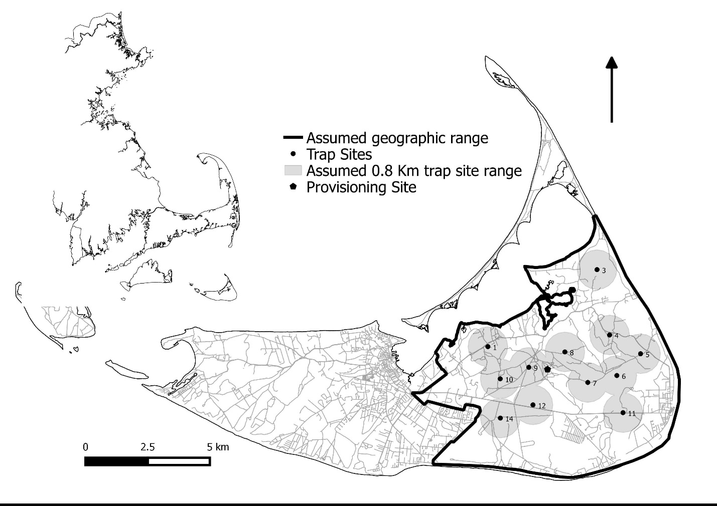

**Fig. 2.** Mean values of δ13C and δ15N (±SE) stable isotope signatures for vertebrate carrion and wild-caught *Nicrophorus americanus* from 2017 and 2018, *Nicrophorus orbicollis*, and *Nicrophorus marginatus*. Values are given for mammal carrion (n = 54), Norway rat carrion (n=7), bird carrion (n = 40), seabird carrion (n=6), and burying beetles (Table 1). Discrimination values have been added to prey items using values determined in a lab-based experiment (J. Creighton unpublished data). For all avian carrion a discrimination value of -1.0 was added for δ13C and +3.0 was added for δ15N. Additionally, for all mammalian carrion a discrimination value of +0.6 was added for δ13C and +3.0 was added for δ15N. Proximity of beetle signatures suggest uses of this carrion for development and growth. Given the location of sea birds in bivariate space, it is highly unlikely that they are being used by burying beetles for reproduction.

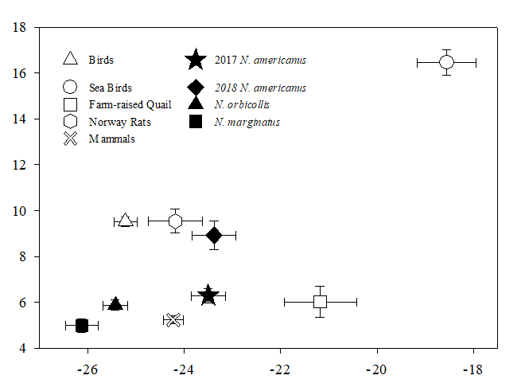

δ13 C

δ15N